**Control and Management of Railway System Connected to Microgrid Stations**

Bugudi Mohan Kumar,​​​ Malireddy Lakshman, Seelam Rajasekhar,

Boya Jolanna Gari Ramakrishna, M Fareed Akram, B. Tech Students,

Dr. K. Chithambaraiah Setty, Professor & HOD, Dept Of EEE,

St. Johns College of Engineering and Technology, Yemminganur.

**ABSTRACT**

The recent railway system is a huge microgrid assembling multiplex structure with distributed active loads, sources and storage devices. The active load represents the train. The sources are a microgrid based on renewable energies. The big problem of the most of electrical train is that they can’t recover energy recovery during regenerative breaking phases. Another problem of the electrical train is the long charging time from the stations. This project suggests a techno-economic process for the energy storage by using SCs in the train, with the aim to reduce the energy consumptions. The proposed design of railway station uses PV and wind sources, and batteries for energy storage system (ESS). For the train, SCs are implemented to the ESS where they are alimented breaking phases and from stations by a pantograph installed in an air power line in each stop. SCs are distinguished by high characteristics power and a wide number of charge/discharge cycles, they provide low particular energy and a fast-charging time. An energy management approach is suggested to control the DC bus by voltage and the buck-boost converter by current. The Sizing of PI controller used for the stabilization of the DC bus of train and station is given. The whole system is modelled in MATLAB-Simulink. Simulations for the train and station show the suitability of the suggested powertrain and control strategy.

**I.INTRODUCTION**

***A. MOTIVATION***

In the last few decades, generally there are growing in energy using and pollutions [1]. The growing number of citizens traveling between cities has implied the continuous development of mass transit systems as buses, taxies, and trains [2]. However, the use of railway transportation systems other conventional means of transport is widely recognized due to the Carrying capacity of a large number of people. The development of rail transportation allows people to travel quickly. Thereby, growing environmental like climate change and CO2 emissions change issues dictate the requisite for ameliorate the performance energy regulation of railway systems [3], [4]. For these raisons, the electric railway traffic has become a principal development management of current public transportation networks [5], [6].

The production of clean energy from renewable sources have become the hot topics of social development [7]. However, railway system integrates different renewable energy sources, like photovoltaics (PV) and wind turbines. To ensure a continuous power supply and to respond to the charge power of train from station to the train, an energy storage system (ESS) is necessary [8], [9]. In order to manage the overload variation in railway power supply structure in the time of heights commuting hours, a wide number of ESS technologies are implemented in the railway system as a constructive means to improve load needs [6], [10]. The on-board storage augmented the weight and space of a vehicle that encourage the underground storage.

SCs represent an appear energy storage devices characterized with a high-power density, a long span life and a wide temperature range, has become the best appropriate storage element match with the functioning characteristics of train system [11] [14]. By comparing SCs to different energy storage devices like batteries and flywheels, SCs present fast charging and discharging time because of the high-power density, and important potential of energy recovery [15]. In general, ESS with SC is considered like energy buffer accelerating mode of train and recycles the excess of power during the braking mode, realizing a good balance of charge and discharge [16]. SCs are considered a best solution in systems which characterized with different fluctuations. SCs are also used in interruptible power systems to stabilized the power and bus voltage. The energy storage in railway system presents a challenge for researches [17], [18].

Energy management system (EMS) is currently a big challenge in large-scale complex 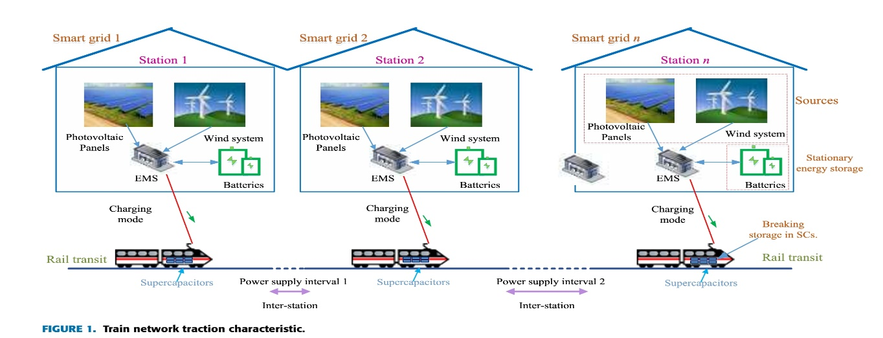energy distribution networks like railway structure. Most of EMS researches in railway structure interest on ameliorating the railway system technologically. EMS on the system level with an integrated strategy into the railway structure often is ignored [19], [20]. The optimal control theory for railway vehicle is presented in many articles [21], [22].

***B. LITERATURE***

The railway system has been studied successfully in many articles by researches such as: Jiang presents a fast inspection method for high-speed railway infrastructure monitoring [23], Feng gives the electric railway smart microgrid system with integration of multiple energy systems and power-quality improvement[24].Khayyam gives railway system energy management optimization demonstrated at offline and online case studies [19], Zhang presents the method using a prediction approach [24], He shown the energy harvesting approach for railway wagon monitoring sensor with high reliability and simple structure [25], Sun presents the hybrid method for life prediction of railway [26], Novak presents the hierarchical model predictive control for coordinated electric railway traction system energy management [27], Sengor gives the energy management of a smart railway station considering regenerative braking and stochastic behaviour of ESS and PV Generation [28].

***C. CONTRIBUTIONS***

The proposed system, is composed of two parts: the first one concern the stations, the second one is addressed to the control of trains. The stations are composed PV and wind elds where the energy storage is insured by batteries. The trains are composed by SCs and engine. SCs are used because of their high power. The innovative contributions given in this article are as follows:

* A design of train implementing SCs for energy storage alimented from stations and breaking phases.
* A new EMS is suggested to control the DC bus by voltage and the buck-boost converter by current.
* Sizing of PI controller used for the stabilization of the DC bus of train and station. A design of railway station using PV and wind sources, and batteries for energy storage

Remainders of project are as follows: system description is depicted in Section II. The system modelling and management is designed in Section II. The simulation and validation expounded in Section IV. In Finally, Section V draws the conclusion.

**II. SYSTEM DESCRIPTION**

***A. GLOBAL SYSTEM DESCRIPTION***

The implementing of the rail transit and energy strategy is illustrated in Fig above. The railway system is constructor of two systems. The first one is stationary system which represents the different stations. Each station is composed by a main energy source which are PV panels and wind system. The energy provided from main sources is stored in batteries. The conversion of energy is insured by boost, buck-boost converters and inverter. Wind system is coupled to the DC bus by an inverter. A boost converter is used to connect PV panels to the DC bus. A buck-boost converter is implemented to couple batteries to the DC bus. The different stations have the same structure and components. The control of the DC bus is insured with an EMS based on PI control. The second one is the mobile system which represents the trains. Each train is composed by motors and supercapacitors. The transfer of energy from SCs to the motors is insured by a buck-boost converter.

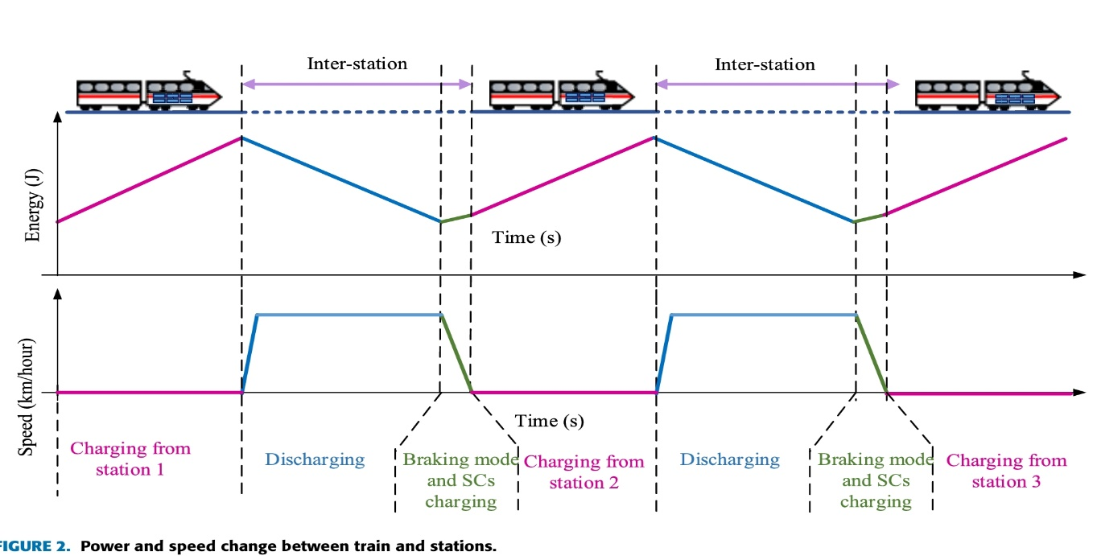***B. DISTRIBUTION OF ENERGY BETWEEN DEVICES***

The exchange of energy between different devices is given in Fig above. The railway system is divided in different stations. The distance between station is more than 10Km. Trains stop in each station between 5 and 15 minutes. During this trains stop, the motors train stop working and SCs charge from batteries installed in the stationary station by a buck-boost converter. The charge of SCs in the stations is insured by the pantograph connected the roof of the trains.

During of the circulation of train between stations, the SCs supply the need of energy. During the braking of the train the energy is returned to SCs. This energy which is produced by different train will be stored locally and produced later in next phases during its acceleration. However, the train in functioning as a load during tracking mode and as a source of the power during braking mode. The stations and trains are connected and mutually communicated.

The different state functioning of rail train engine resolves the form of electrical power exchange. During the traction of the engine, the alternator mode, the train is in the acceleration conditions. In this case, the electric power circle in the forward direction, that is transformed into kinetic energy from the traction system. during the traction engine, the power generation phase, the train is in braking and deceleration mode. At this moment, the electric energy circle in the inverse direction, and the kinetic energy given by the train during braking is used by the auxiliary installations of the train itself, with most of them being fed back to the SCs and used by the train in the same power supply phase.

The installation of the storage devices reduces the energy line losses, because the power circle though the line is minimized, and the smoother voltage pro les without the request of changing the infrastructure of the structure. The implementation of SCs on a vehicle however need a large space, adding at the same time extra weight that can affect significantly the dynamic specifications of the train.

The train power is 3.5MW. The energy delivered by SCs is estimated at approximately 210MJ (corresponding to 3.5MW for 60 s).

**III. SYSTEM MODELLING AND ENERGY MANAGEMENT**

The DC bus is controlled according to the diagram given in Fig above. The EMS is divided in two parts, the first one is the control of the stationary system and the second in the train.

For the stationary system, the wind system produces a AC power. It is coupled to the DC bus by using an AC-DC inverter. The PV system is implemented to the same bus by using a Boost converter. An MPPT maximum power point tracking system is implemented to stabilized the PV power and voltage. A Buck-Boost converter is applied to stabilized the DC bus voltage VdS and to charge the batteries. A line transmission is presented by a resistance and inductance. For the train system, a Buck-Boost converter is implemented to couple batteries to SCs. Another Buck-Boost is implemented to couple SCs train engine and to stabilize the voltage to 2KW. A capacitor is implemented in parallel to the engine and the buck-boost converter in order to filter the power fluctuation from the converters. The EMS gives the control of the converters. The mathematical modelling of PV and wind system are given in Table above. The mathematical modelling of SCs and batteries are given in Table above. The chosen SCs model two branches model. The using batteries model is CIMAT batteries.

The buck-Boost converter is reversible in current. The modelling of this converter is given in Fig above [8]. In the active phase, the switch is closed, the input voltage is given by:

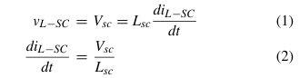

where LSC is the inductance, VSC is the SCs voltage, Cdc SC is the SCs buck-boost capacitor.

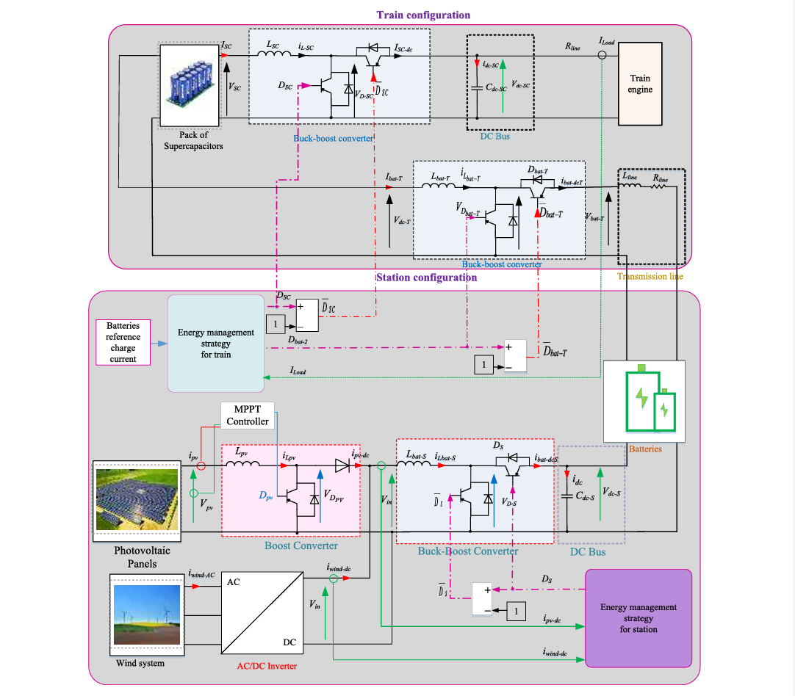

In the Freewheeling phase, the switch is open and the inductor current cannot fluctuate instantaneously. The input voltage is de ned by the following equations:

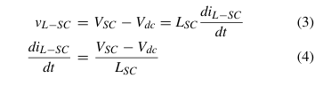

The main equation of the buck-boost converter is given by:

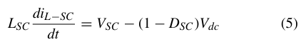

**IV. CONTROL OF THE DC BUS VOLTAGE OF DIFFERENT SYSTEMS OF TRAIN AND STATION**

The principle of the control system of SC, train and stationary system are described in Fig above. The PI controllers F(s), H(s) and J(s) calculate the reference 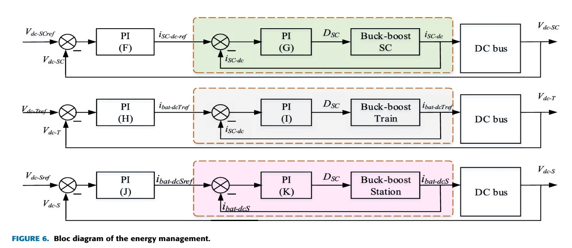current of the DC bus of SC system, the train system 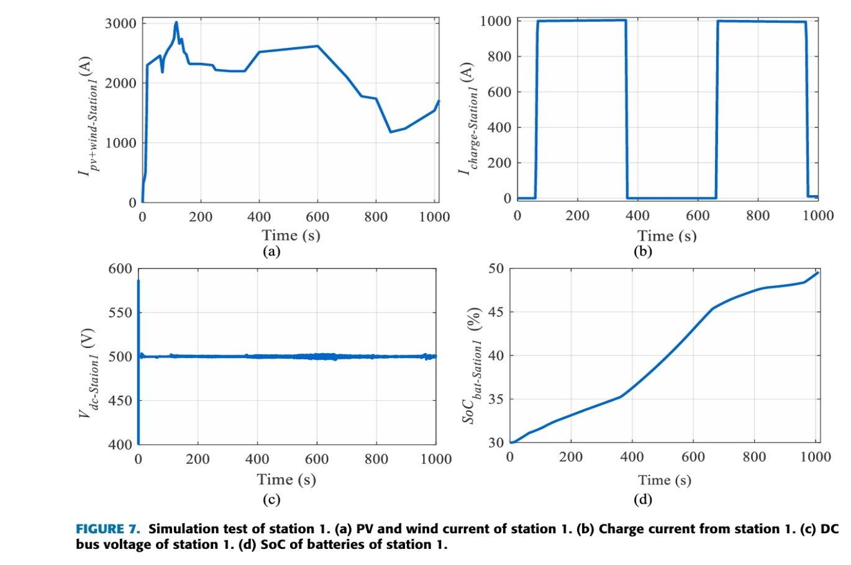and the stationary system, Isc-dc ref, ibat-dcT ref and

ibat-dcS ref, respectively. The PI controllers G(s), I(s) and K(s) calculate the duty cycle of SC system DSC, train system DT and the stationary system DS, respectively.

The management of the three DC bus is insured with a voltage control. The calculating of the parameters of this PI controller(F(s), H(s) and J(s)) is given by the following equations:

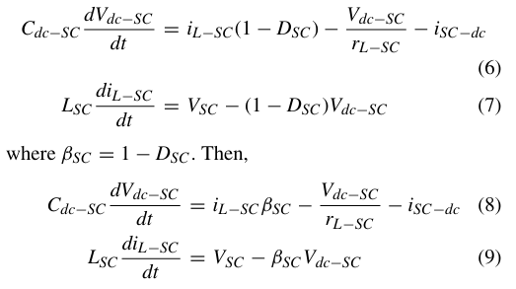Thereby, the dynamic equation is expressed as:

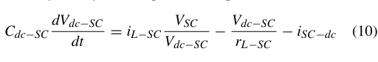

By supposing X V2 dc SC is replaced, the linear function is expressed by:

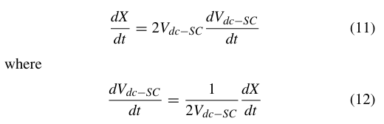

The main equation is given:

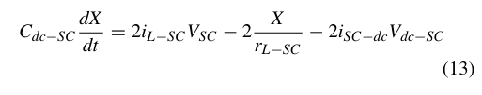

The TF (transfer function) of between voltage and current in Laplace domain is given by:

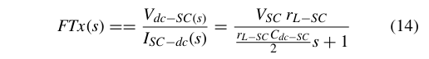

The TF of the SC system is represented by

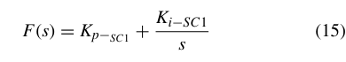

Where Ki-SC1 and Kp-SC1 are the integral and proportional gain used for SCs system control, respectively.

The TF of the train system is represented by



Ki-T1 and Kp-T1 are the integral and proportional used for the train system control, respectively. The transfer function of the stationary system is expressed by the following equation



Equation (14) and (15) we deduce the following expression:

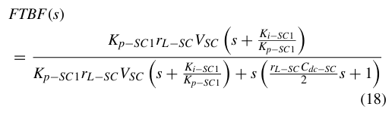 which gives (19), as shown at the bottom of the next page. The closed-loop transfer function is the SC system is given by (20), as shown at the bottom of the next page. By identifying the denominator with that of the canonical form the SC system, we deduce

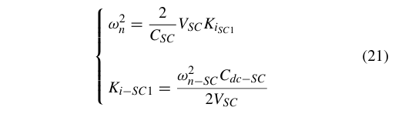

Where

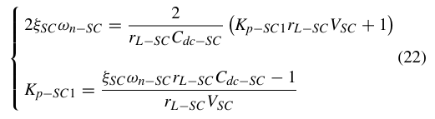

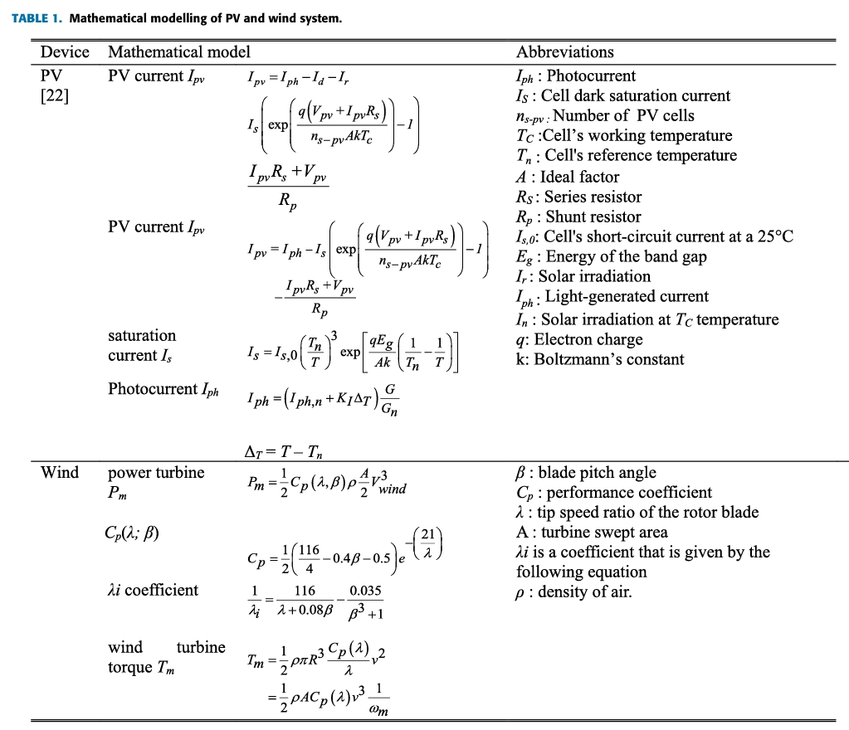where n SC is the pulsation for SC system, SC is the damping coefficient for SC system.

Ki-T1 and Kp-T1 are the integral and proportional used for the train system control, respectively. They are expressed by:

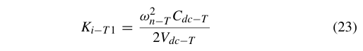

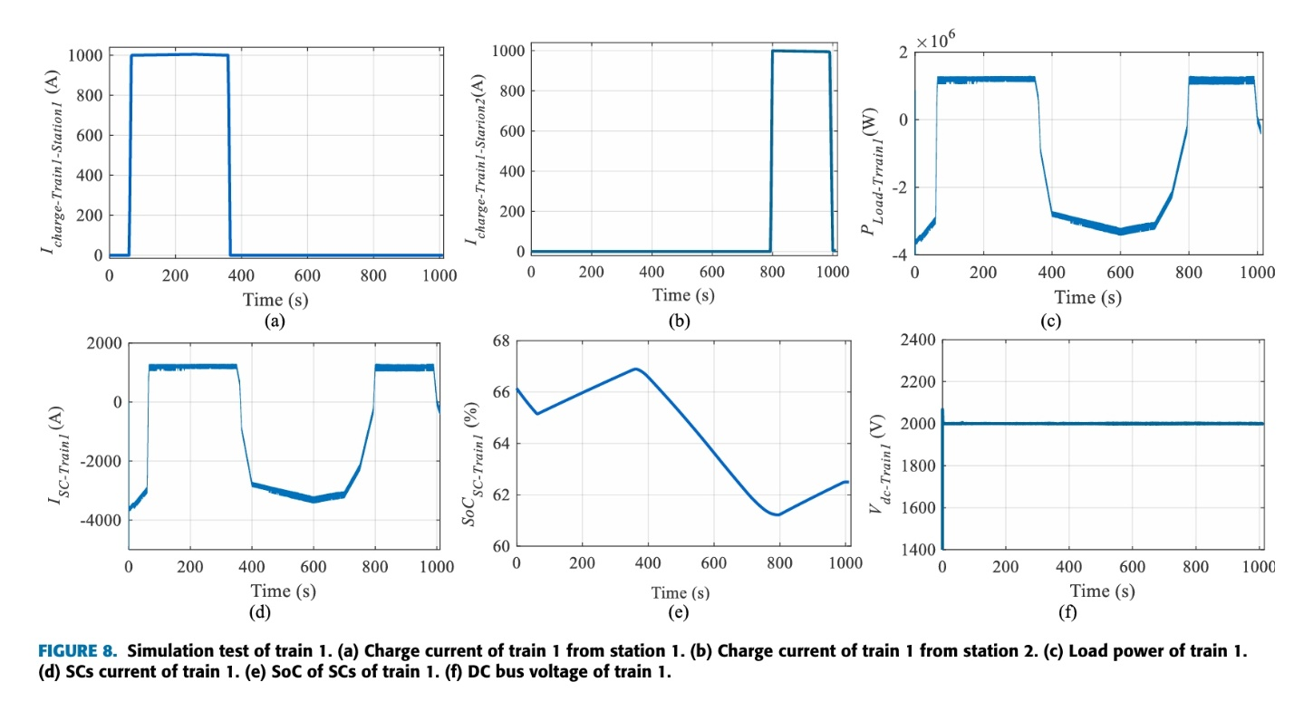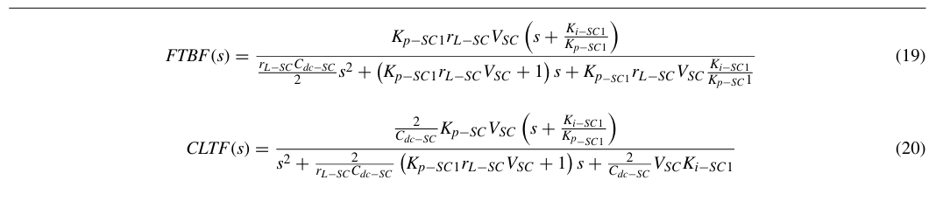



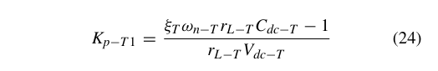

where n SC is the pulsation used for train system, SC is the damping coefficient used for train system.

Ki-S1 and Kp-S1 are the integral and proportional gain used for the stationary system control, respectively. They are expressed by:

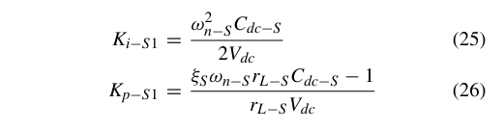where n SC is the pulsation used for stationary system, SC is the damping coeff cient used for stationary system. The control of the buck-boost converter is insured by a current control. The calculating of the parameters of this PI controller (G(s), I(s) andK(s)) is given by the same methodology and is represented by the following equations:

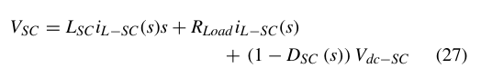

The DSC and ISC is expressed as follows:

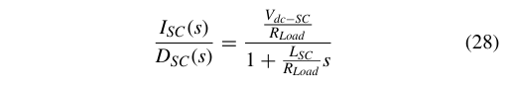

The TF of the SC system is given by the following equation:

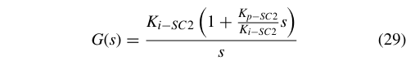

The TF of the stationary system is expressed by the following equation:

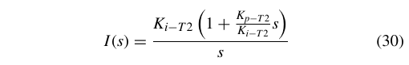

The TF of the stationary system is expressed by the following equation:

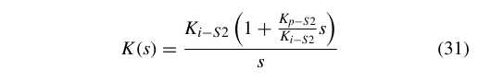

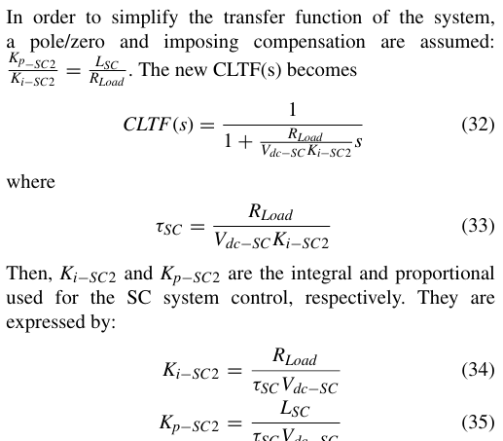

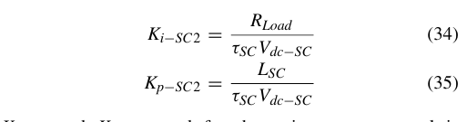

Ki-T2 and Kp-T2 used for the train system control is ex

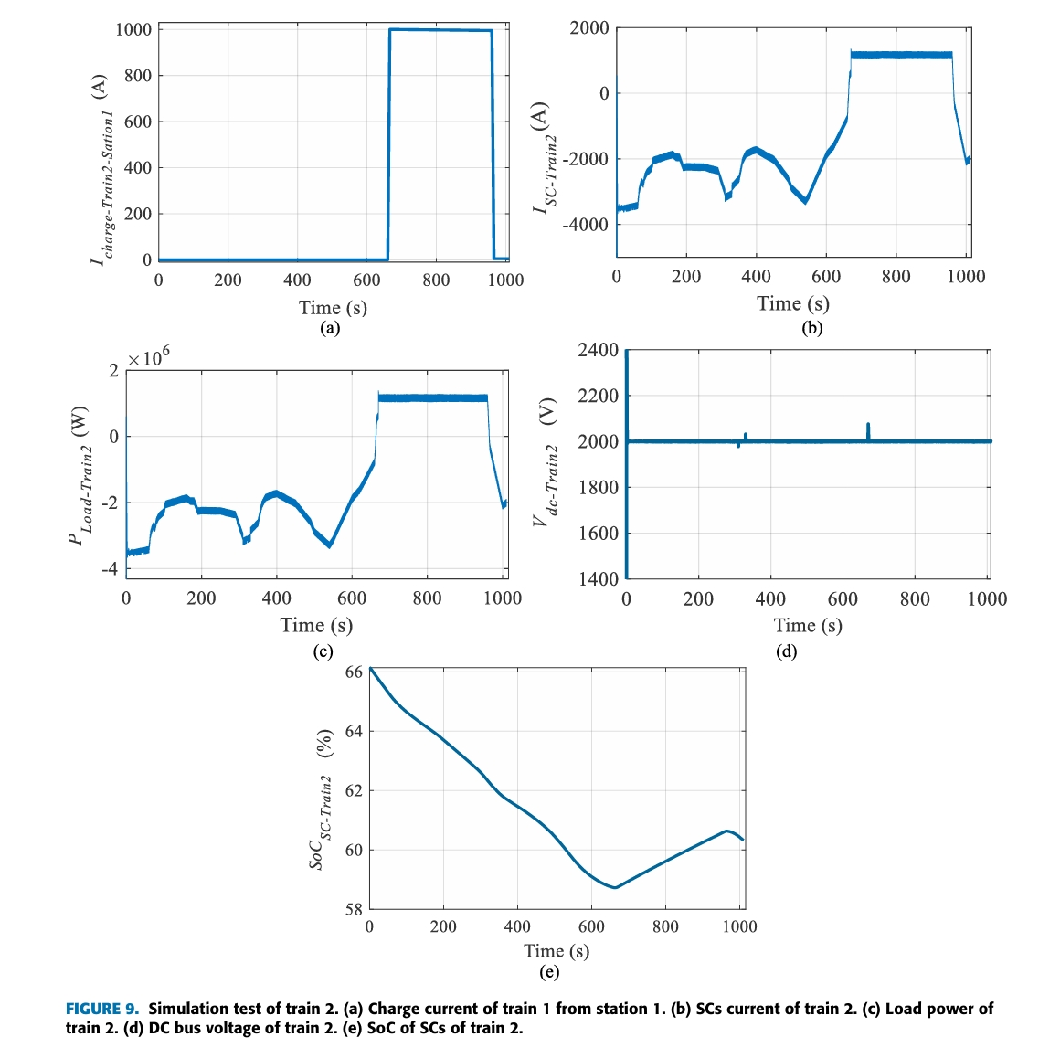

**V. SIMULATION RESULTS**

For test the feasibility of the presented strategy, a model of the whole system is built by Matlab Simulink software.The proposed simulation test is presented by one station (station1) and two trains (train1 and train2). The simulation tests are proposed with the same parameters of trains and stations during1000s. The scenario of wind, solar irradiation and temperature is proposed variable.

The initial state of charge of batteries used in station1is SoCbat-Station1 = 30%.

The initial state of charge of SCs used in train 1 is SoCSC-Train1 = 66%.

The initial state of charge of SCs used in train 2 is SoCSC-Train2 = 66%.

Fig.7 represents the simulation test of station1. This station is proposed by amicrogrid using PV and wind as a sources. The energy storage is insured by batteries. Fig.8 and 9 represent the simulation tests of train1 and train2, respectively. In this simulation test, train1 and train 2 charge from station1 in different duration. Train1 reach station1 at t=50s and train 2 reach station 1 at t=650s. Fig.7(a) represents the PV and wind current that is varied between 1200A and 3000A.

The charge current of station1 is illustrated in Fig.7(b). Train1 charge from station 1 between t=50s and t=350s with a constant current of Icharge-Station1 1000A for a duration of five minutes. Train2 charge from station1 betweent t=650s and t=950s with a constant current of Icharge-Station1 = 1000A for a duration of five minutes. The DC bus voltage of station1 in given inFig above(c). It is fixed at 500V.The state of charge of batteries of station1 is given in Fig.7(d). It is represented between 30% and 50%. Train1 charge from station1 between t=50s and t=350s, and charge from station2 between t=800s and t=1000s. The charge current of SCs from station1 and 2 used for train 1 is given in Fig.8 (a and b), respectively. Power and current of SCs are shown in Fig.8 (c and d), respectively. The power and current are positive and constant in the charging mode and negative in the traction mode. The DC bus voltage of train1 is 2000V and is given in Fig.8(e). The state of charge of SCs of train 1 is given in Fig above(f). It varies between 61% and 67% that represents an augmentation during charging mode and reduction during traction mode.

Train2 charge from station1 between t=650s and t=950s. The charge current of SCs from station2 used for train2 is given in Fig above(a). The power and SCs current are represented in Fig above(b and c), respectively. The DC bus current of train 1 is 2000V and is given in Fig above(d). The stat of charge of SCs of train 1 is given in Fig above(e). It varies between 69% and 66% that represents an augmen tation during charging mode and reduction during traction mode.

The simulation results proof that the proposed energy management system and control system give good results.

**VI. CONCLUSION**

The proposed techno-economic method for the energy storage by using SCs in the train was presented in this project. The studied system is devised on two parts: station and train. The design of railway station is presented by using PV and wind as principal sources, and batteries for ESS. The train is composed by engine and SCs. SCs are implemented to the ESS of the train, where they are alimented from the breaking phases and the stations by a pantograph installed in an air power line in each stop. SCs are used for their fast charge and discharge. An EMS is given in order to stabilized the DC bus. The calculation of parameters of the buck-boost converter are given. The Sizing of the integral and proportional gain controller used for the stabilization of the DC bus of train and station is given. A simulation test was proposed with one station and two trains. The trains recharge from the station in different times. The obtained results showed that the given EMS and system design give good results in order to stabilized the DC bus voltage and reply to the need of energy by the engine. The future work will be reserved to the application of this system with AC engine.

**REFERENCES**

[1] G. Cui, L. Luo, C. Liang, S. Hu, Y. Li, Y. Cao, B. Xie, J. Xu, Z. Zhang, Y. Liu, and T. Wang, Supercapacitor integrated railway static power conditioner for regenerative braking energy recycling and power quality improvement of high-speed railway system, IEEE Trans. Transport. Electri c., vol. 5, no. 3, pp. 702714, Sep. 2019.

[2] F. Ciccarelli, A. Del Pizzo, and D. Iannuzzi, Improvement of energy ef ciency in light railway vehicles based on power management control of wayside lithium-ion capacitor storage, IEEE Trans. Power Electron., vol. 29, no. 1, pp. 275286, Jan. 2014.

[3] V. A. Kleftakis and N. D. Hatziargyriou, Optimal control of reversible substations and wayside storage devices for voltage stabilization and energy savings in metro railway networks, IEEE Trans. Transport. Electri c., vol. 5, no. 2, pp. 515523, Jun. 2019.

[4] T. Ratniyomchai, S. Hillmansen, and P.Tricoli, Recent developments and applications of energy storage devices in electried railways, IET Elect. Syst. Transp., vol. 4, no. 1, pp. 920, Mar. 2014.

[5] H. Yang, W. Shen, Q. Yu, J. Liu, Y. Jiang, E. Ackom, and Z. Y. Dong, Coordinated demand response of rail transit load and energy storage system considering driving comfort, CSEE J. Power Energy Syst., vol. 6, no. 4, pp: 749-759, Dec. 2020.

[6] H. Yang, J. Zhang, J. Qiu, S. Zhang, M. Lai, and Z. Y. Dong, A practical pricing approach to smart grid demand response based on load classi cation, IEEE Trans. Smart Grid, vol. 9, no. 1, pp. 179190, Jan. 2018.

[7] Z. Cabrane, M. Ouassaid, and M. Maarou, Analysis and evaluation of battery-supercapacitor hybrid energy storage system for photovoltaic installation, Int. J. Hydrogen Energy, vol. 41, no. 45, pp. 2089720907, Dec. 2016.

[8] Z. Cabrane, J. Kim, K. Yoo, and M. Ouassaid, HESS-based photovoltaic,batteries and supercapacitors: Energy management strategy and DC bus voltage stabilization, Sol. Energy, vol. 216, pp. 551563, Mar. 2021.

[9] Q. Z. Li, X. J. Wang, X. H. Huang, Y. Zhao, Y. W. Liu, and S. F. Zhao, Research on ywheel energy storage technology for electri ed railway, Proc. CSEE, vol. 39, no. 7, pp. 2025 2033, Apr. 2019. [10] H. Yang, Q. Yu, J. Liu, Y. Jia, G. Yang, E. Ackom, and Z. Y. Dong, Optimal wind-solar capacity allocation with coordination of dynamic regulation of hydropower and energy intensive controllable load, IEEE Access, vol. 8, pp. 110129110139, 2020.

[11] M. Andriollo, R. Benato, M. Bressan, S. Sessa, F. Palone, and R. Polito, Review of power conversion and conditioning systems for stationary electrochemical storage, Energies, vol. 8, no. 2, pp. 960975, Jan. 2015, doi: 10.3390/en8020960.

[12] K. C. Divya and J. Østergaard, Battery energy storage technology for power systems An overview, Electr. Power Syst. Res., vol. 79, no. 4, pp. 511520, Apr. 2009.

[13] I. Hadjipaschalis, A. Poullikkas, and V. Efthimiou, Overview of current and future energy storage technologies for electric power applications, Renew. Sustain. Energy Rev., vol. 13, nos. 67, pp. 15131522, 2009.

[14] Z. Cabrane and S. H. Lee, Electrical and mathematical modeling of supercapacitors: Comparison, Energies, vol. 15, no. 3, p. 693, Jan. 2022.

[15] Z. Cabrane, M. Ouassaid, and M. Maarou, Battery and supercapacitor for photovoltaic energy storage: A fuzzy logic management, IET Renew. Power Gener., vol. 11, no. 8, pp. 11571165, 2017.

[16] Z. Yang, F. Zhu, and F. Lin, Deep-reinforcement-learning-based energy management strategy for supercapacitor energy storage systems in urban rail transit, IEEE Trans. Intell. Transp. Syst., vol. 22, no. 2, pp. 11501160, Feb. 2021.

[17] D. Roch-Dupré, T. Gonsalves, A. P. Cucala, R. R. Pecharromán, Á. J. López-López, and A.Fernández-Cardador, Multi-stage optimization of the installation of energy storage systems in railway electrical infrastructures with nature-inspired optimization algorithms, Eng. Appl. Artif. Intell., vol. 104, Sep. 2021, Art. no. 104370.

[18] H.Lee, S. Jung, Y. Cho, D. Yoon, and G. Jang, Peak power reduction and energy efficiency improvement with the superconducting flywheel energy storage in electric railway system, Phys. C, Supercond. Appl., vol. 494, pp. 246249, Nov. 2013.

[19] S. Khayyam, N. Berr, L. Razik, M. Fleck, F. Ponci, and A. Monti, Railway system energy management optimization demonstrated at offline and online case studies, IEEE Trans. Intell. Transp. Syst., vol. 19, no. 11, pp. 35703583, Nov. 2018.

[20] Z. Cabrane, J. Kim, K. Yoo, and S. H. Lee, Fuzzy logic supervisor based novel energy management strategy re ecting different virtual power plants, Electr. Power Syst. Res., vol. 205, Apr. 2022, Art. no. 107731.

[21] H. Peng, J. Li, L. Lowenstein, and K. Hameyer, strategy based on optimal control theory for a fuel cell hybrid railway vehicle, Appl.Energy, vol. 267, Jun. 2020, Art. no. 114987.

[22] X. Jiang and S. Wang, Railway panorama: A fast inspection method for high-speed railway infrastructure monitoring, IEEE Access, vol. 9, pp. 150889150902, 2021.

[23] C. Feng, Z. Gao, Y. Sun, and P. Chen, Electric railway smart microgrid system with integration of multiple energy systems and power quality improvement, Electr. Power Syst. Res., vol. 199, Oct. 2021, Art. no. 107459.

[24] Q. Zhang, Z. Yuan, L. Yan, T. Zhang, Y. Miao, and S. Ding, A railway train number tracking method using a prediction approach, IEEE Access, vol. 7, pp. 138288138298, 2019. ]

[25] W. He, W. Shi, J. Le, H. Li, and R. Ma, Geophone-based energy harvesting approach for railway wagon monitoring sensor with high reliability and simple structure, IEEE Access, vol. 8, pp. 35882 35891, 2020.

[26] Y. Sun, Y. Cao, M. Zhou, T. Wen, P. Li, and C. Roberts, A hybrid method for life prediction of railway relays based on multi-layer decomposition and RBFNN, IEEEAccess, vol. 7, pp. 4476144770, 2019.